City of Salem, Massachusetts

Request for Proposals

RFP 23-09-TAP

Downtown Parking Analysis

July 25, 2022

PROPOSALS DUE:

Tuesday, August 9, 2022
11:00AM

*Late proposals will be rejected

Anthony Delaney
93 Washington Street, 2nd Floor
Salem, MA 01970
adelaney@salem.com
(978) 619-5695

Request for Proposals 23-09-TAP
Downtown Parking Analysis
Cover Sheet

Proposer: | _________________________________________________________________
Street Address: | _______________________________ | _____________ |  | ________ | _______
 | (Number and Street) | (City) |  | (State) | (Zip)
Taxpayer
Identification No: | _________________________________ |  | _______________________________
 | (Social Security Number) |  | (Federal Identification Number)
Contact Name: | _________________________________________________________________
Telephone: | _________________________________________________________________
Email Address: | _________________________________________________________________
Fax: | _________________________________________________________________
Authorized
Signature: | __________________________________________________________________
Name: | __________________________________________________________________
Title: | __________________________________________________________________
Date: | __________________________

REQUEST FOR PROPOSALS 23-09-TAP
Downtown Parking Analysis
Checklist
Submissions:
- Completed Cover Sheet
- Checklist
- Price Proposal Form (separate, sealed envelope)
- Non-Price Proposal
  - Signed Certificate of Non-Collusion
  - Signed Tax Compliance Certification
  - Signed Certificate as to Corporate Bidder (if applicable)
- Acknowledgement of Addenda: __________ (if applicable)

Request for Proposals 23-09-TAP
Downtown Parking Analysis
Price Proposals

Proposer agrees to perform the scope of services described herein for the following total price. Price below shall be inclusive of all costs associated to perform the tasks as outlined in this RFP, including, but not limited to, any incidental costs such as travel, meal, copying, printing, and mailing expenses.
$_____________________________________________________________________________
(figures)
_______________________________________________ DOLLARS AND ________________
_______________________________________________ CENTS.
(written)

The total price above is further broken down by Task below (may attach spreadsheet) Total price must not exceed $90,000.

Task | Fixed Fee Per Task | Cost Breakdown for Fee - Hourly Rate for each staff person assigned to task and estimated hours needed for work. If reimbursable or subconsultant expense, please provide cost and markup. (May attach separate breakdown)
1: Information Collection and Analysis: Museum Place and South Harbor Parking Garages
2: Information Collection and Analysis: Existing Market Conditions and Projected Future Development
3: Existing Conditions of Alternative Parking Sites
4. Buildout and Parking Capacity Assessment
5. Public Presentation(s): Kick-Off Meeting and Final Report
Add Alternative 1. Conceptual Study for Development and Parking at Klopp Alley/Front Street

_____________________________________________________
Signature of Authorized Representative

_____________________________________________________
Name (Printed)

____________________
Date
Request for Proposals 23-09-TAP
Downtown Parking Analysis
Required Forms

FORM A
NON-COLLUSION

The undersigned certifies under penalties of perjury that this bid or proposal has been made and submitted in good faith and without collusion or fraud with any other person. As used in this certification, the word "person" shall mean any natural person, business, partnership, corporation, union, committee, club, or other organization, entity, or group of individuals.

____________________________________________
(Signature of authorized individual submitting proposal)
____________________________________________
(Printed Name)
____________________________________________
(Name of Proposer)
____________
(Date)

FORM B
TAX COMPLIANCE

Pursuant to M.G.L. c. 62C, §49A, I certify under the penalties of perjury that, to the best of my knowledge and belief, I am in compliance with all laws of the Commonwealth relating to taxes, reporting of employees and contractors, and withholding and remitting child support.

____________________________________________
(Signature of authorized individual submitting proposal)
____________________________________________
(Printed Name)
____________________________________________
(Name of Proposer)
____________________________________________
(Federal Tax Identification or Social Security Number)
____________
(Date)

FORM C
CERTIFICATE OF CORPORATE AUTHORITY (if applicable):

I, _______________________________ certify that I am the _____________________ of the corporation named as Bidder in the Bid included herein, that _________________, who signed said Bid on behalf of the Bidder was then ________________________ of said corporation, that I know his signature, that his signature thereon is genuine and that said Bid was duly signed, sealed and executed for and in behalf of said corporation by authority of its governing body.

(Corporate Seal)
_____________________________
(Secretary-Clerk)

____________________________________________
(Signature of authorized individual submitting proposal)
____________________________________________
(Printed Name)
____________________________________________
(Name of Proposer)
____________
(Date)

Part 1. General Information

1.1 PROCUREMENT DESCRIPTION

The City of Salem is seeking proposals from qualified interdisciplinary teams to develop a strategy and plan for the provision of downtown Salem’s future public parking infrastructure and any associated development opportunities over the mid- to long-term. See Part 3 for a detailed project scope.

The work described in the scope of services identified herein must be completed no later than nine months from the issuance of a Notice to Proceed. The City has established a budget not to exceed $90,000.

1.2 APPROVAL

Any contract that may result from the procurement shall be subject to the approval of the Mayor of the City of Salem.

All insurance requirements shall be met prior to executing a contract and a Certificate of Insurance will be collected at the time of contract execution. Failure to meet the insurance requirements as outlined in the contract may be cause for the City to rescind its award. See Attachment 1 for a sample contract.

1.3 INCORPORATION BY REFERENCE

All requirements, specifications, terms, and conditions described in this Request for Qualifications (‘RFQ’) shall be incorporated by reference into any contract that may result.

1.4 TIME FOR AWARD

Any contract that may result from the procurement shall be awarded within forty-five (45) days after the proposal due date. The time for award may be extended for up to 45 additional days by mutual agreement between the City and the most advantageous proposer.

1.5 RIGHT TO CANCEL/REJECT

The City reserves the right to cancel this RFQ or reject in whole or in part any and all proposals if the City determines that cancellation or rejection serves the best interests of the City.

1.6 TAXATION

Purchases made by the city are exempt from the payment of Federal excise tax and the payment of Commonwealth of Massachusetts sales tax and any such taxes must not be included in the proposal pricing.

Copies of the City’s tax-exempt documentation shall be available upon request of the selected contractor.
Part 2. Instructions to Proposers

2.1 REQUIREMENTS AND SUBMISSIONS

Below, please find a description of the requirements and submissions that must be included as part of your proposal.

2.1.1 PROPOSAL COMPONENTS

The following items must be submitted for the proposal to be considered:

- Cover Letter-Include a statement of interest and the signatory’s authority to bind the consultant.

- Project Narrative – Please respond concisely to the items under Submittal Requirements, Section 2.5.

- Price Proposal – Please fill out the Price Proposal form.

2.2 PROPOSAL DELIVERY

Below please find a description of the manner in which proposals must be submitted.

2.2.1 DUE DATE AND TIME

Proposals shall be received by email by the City of Salem Purchasing Department on or before Tuesday, August 9, 2022 at 11:00am.

Any proposal received after that time shall be rejected as non-responsive. For matters of uniformity, the email receipt date shall be the sole determinant of time.

2.2.2 ADDRESS

Proposals shall be delivered electronically to Anthony Delaney, Chief Procurement Officer for the City of Salem at adelaney@salem.com.

2.3 SIGNATURES

A proposal must be signed as follows:
- if the proposer is an individual, by her/him/them personally,
- if the proposer is a partnership, by the name of the partnership, followed by the signature of each general partner, and
- if the proposer is a corporation, by the authorized officer, whose signature must be attested to by the clerk/secretary of the corporation, and with the corporate seal affixed.

Signed pages must be scanned and incorporated into the electronic submittal package.

2.4 QUESTIONS, CHANGES, MODIFICATIONS AND WITHDRAWALS

2.4.1 QUESTIONS

Questions concerning this RFQ must be submitted in writing to: Anthony Delaney, Purchasing Agent, at adelaney@salem.com at least five (5) days prior to the submittal deadline.

2.4.2 CHANGES

Any changes to this RFQ will be sent via email to those who requested a copy of the RFQ.

2.4.3 MODIFICATIONS AND WITHDRAWALS

A proposer may correct, modify, or withdraw a proposal by written notice received by the City of Salem prior to the proposal due date.

Modifications must be clearly labeled "Modification No.__" and must reference this RFQ.

After the proposal due date, a proposer may not change any provision of the proposal in a manner prejudicial to the interests of the City or fair competition. Minor informalities will be waived, or the proposer will be allowed to correct them.

2.5 NARRATIVE SUBMITTAL REQUIREMENTS
Please provide the following information:
- Proposer Information:
    - Firm name, address, and staff assigned.
    - Relevant registration and/or license numbers. Indicate if your firm is certified by the Supplier Diversity Office.
    - Experience of Firm and staff assigned. Concisely document specific examples of relevant work and provide resumes for principals and staff that will be working on this project.
    - List all projects undertaken within the past two (2) years with references.
    - If there are subconsultants, provide their name, address, specialty, and experience. Indicate if they are certified by the Supplier Diversity Office.

- Project Plan: Provide a brief and concise description of your approach to each task. This project plan must demonstrate an understanding of the project and each task, and how each will be accomplished.

- Project Schedule: Provide a proposed schedule including details on each deliverable and subtasks.

- Proposed Fee: Complete the Price Proposal Form (page 2 of this RFQ). Attached additional sheets if necessary. The fee for this project may not exceed $90,000.
    - Note reimbursables that are covered or not.
    - Discuss what is included in your fee (reimbursable, survey, etc.) and what is in addition.

2.6 Project Schedule
The anticipated start date for work resulting from this procurement is Fall 2022. Said work must be completed within nine months of the Notice to Proceed. The selected firm’s proposed detailed schedule is subject to review and approval by the City of Salem.

Part 3. Project Scope

I. INTRODUCTION

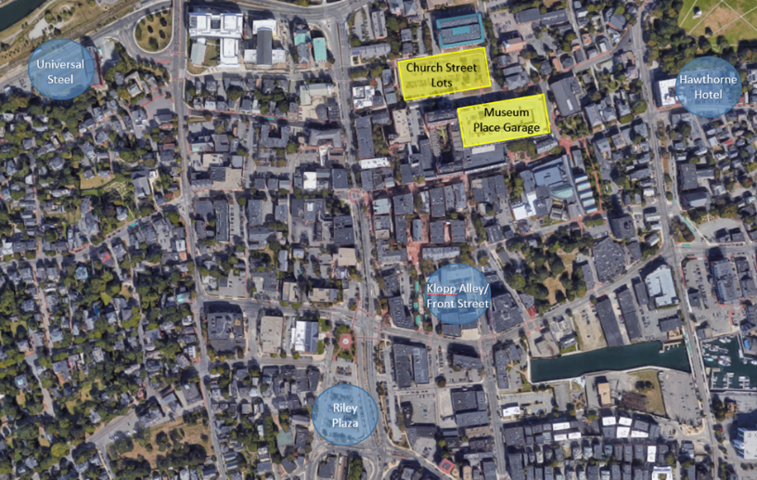
A. Project Objective
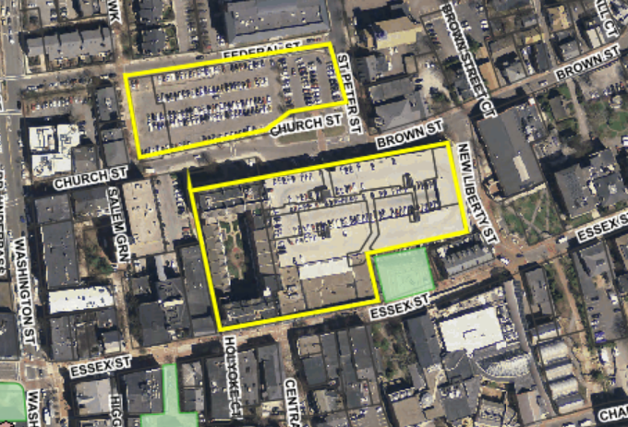
To develop a strategy and plan for the provision of downtown Salem’s future public parking infrastructure and any associated development opportunities over the mid to long term. The plan will serve as a key resource, a ‘road map’, for decision-making regarding changes to the parking system, redevelopment opportunities, and financing approach. Because of the long-term nature, the analysis needs to consider the eventual replacement of existing structured public parking supply (e.g., Museum Place and South Harbor Garages) as well as a possible paradigm shift in parking demands that takes into account advancements in payment and vehicle technology as well as the introduction and expansion of other mobility options. The scope involves analyzing several sites for possible parking structures, indicating which sites are most cost effective for parking, and identifying which sites are likely to best lend themselves to development in addition to parking. An expanded conceptual development study of the Klop Alley/Front Street lot is also needed and could be a second phase of this project if appropriate. Near-term recommendations on potential regulatory and operational changes are also to be included.
Overview of Study Area

B. The Study Area
Church Street Parking Lot and Museum Place Garage
The study area is downtown Salem, generally. Specifically, the sites to be analyzed are:
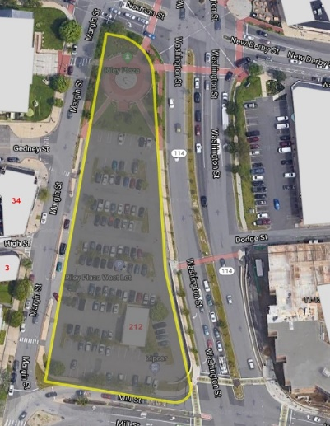
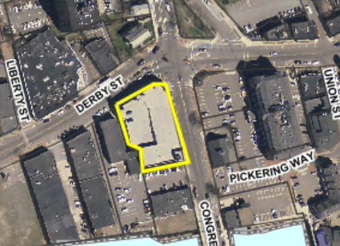
- Universal Steel – 297 Bridge Street, City-owned
- Riley Plaza – 212 Washington Street, City-owned
- Klopp Alley/Front Street, City and SRA-owned
- Church Street – East and West surface lots, SRA-owned
South Harbor Garage
Riley Plaza
- Hawthorne Hotel – 18 Washington Square West, privately owned. The property owner has indicated interest in participating in this study.

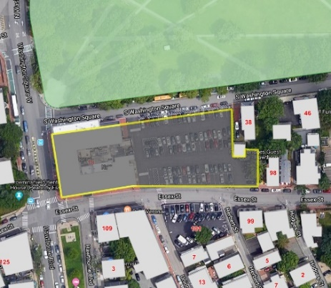
II. Scope of Work
The Scope of Work is intended as a guide for consultants preparing proposals. Specific sub-tasks may be modified by the consultant to better address the project objective.
Task 1: Information Collection and Analysis: Museum Place and South Harbor Parking Garages

- Collect and review historical usage data (at least two years of pre-COVID data) for the following data points for both of the municipal parking garages:
- Occupancy rates
- Pass versus daily users
Hawthorne Hotel
- Pass users that are residential pass holders versus commuter parking pass holders
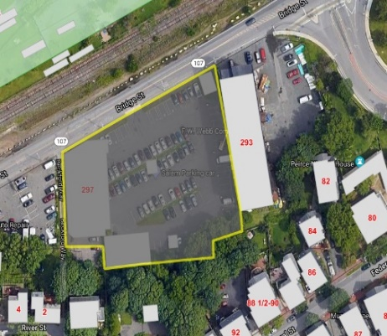
- Revenue and expense data
1.2 Review existing condition assessments:
- Review 2017 RFP and subsequent 2018 condition assessment by Walker Consultants (Museum Place Garage)
  - Review 2020 condition assessment by DiGiorgio Associates Incorporated (South Harbor Garage)
  - 2020 Sealing Project Specifications (Museum Place Garage)

Task 2: Information Collection and Analysis: Existing Market Conditions and Projected Future Conditions
Universal Steel

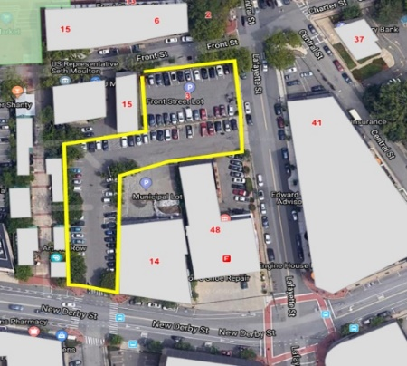
2.1 Review of recent development patterns and market conditions in the study area.
2.2 Cursory review of downtown development opportunities, mixed-use and residential, to determine realistic assumptions on tax generation and parking needs.
2.3 Broad survey of research regarding potential future transportation technologies (including but not limited to space sensors, payment technologies, micro-mobility connections, autonomous vehicles/connected vehicles, etc.) and their impacts on parking demand, curb use, and parking management. Analysis of these impacts on projected future conditions in Salem.

Task 3: Existing Conditions of Alternative Parking Sites
Front Street/Klop Alley
For each site compile the following information:
  - Zoning and other applicable local and state regulations,
    - Land use,
    - Existing utilities and infrastructure,
    - Easements – surface and subsurface,
    - Permits for work on/under the site(s) from other government entities, i.e. the permitting for the MBTA tunnel under Washington Street,
    - Connectivity – capacity and physical state of roads/sidewalks to/from site, and
    - Environmental conditions – soils, hazardous materials, flood plain vulnerability.

Task 4: Buildout and Parking Capacity Assessment

For each site, with assistance from City staff, determine the following:
- Size/capacity of a parking facility on the site,
- Interior circulation,
- Vehicular and pedestrian access to/from the facility,
- Peak hour flow,
- Potential traffic concerns/issues,
- Shared parking opportunities,
- Optional site opportunities (i.e. mixed-use wrapping facility or topping facility (or both) with complementing uses),
- Potential to integrate new technologies into the facility to improve efficiency or extend useful life,
- Potential for conversion to different uses (i.e. can structure be retrofitted into office use if demand for parking decreases over time due to economic/technological changes), and
- Preliminary site plan showing facility footprint, and
- Cost estimate per space.

Task 5: Public Presentations for Kick-Off Meeting and Final Report

Attendance at up to two public meetings, likely joint meetings of the Salem Redevelopment Authority and the Salem Parking and Traffic Commission to kick off the project and to present the final report and solicit feedback. In-person attendance is preferred if safe, though remote meeting attendance may be considered.

The consultant shall solicit feedback on the report at the meeting(s) and respond to and/or incorporate comments into the final report as appropriate. The final report shall include the consultant’s recommendations on parking strategy, including details on potential phased approaches to a downtown parking plan.

Add Alternative Task 1: Conceptual Study for Development and Parking at Klopp Alley/Front Street

The adjacent Central Fire Station needs significant capital improvements. The City would like the consultant to consider integrating the fire station with parking and new development on the adjacent publicly-owned parking lots.

Part 4. Evaluation and Selection

4.1 MINIMUM REQUIREMENTS

All participants must meet the following minimum requirements:
 | Yes | No
- Proposer must submit a complete proposal in accordance with this RFP.
- Civil Engineers, Structural Engineers, and any other applicable designers must be licensed and registered in Massachusetts.
- Must have at least three years’ experience in similar projects and services, including a minimum of three or more similar projects bid under Massachusetts public procurement laws.

4.2 COMPARATIVE EVALUATION CRITERIA

1. Project Approach
Highly Advantageous | Demonstrates superior understating of all aspects of the scope of work and addresses each task.  Balances creative and practical design solutions.  Provides highly credible strategy for completing project on time and within budget.
Advantageous | Demonstrates adequate understating of all aspects of the scope of work.  Balances creative and practical design solutions in limited manner.  Provides credible strategy for completing project on time and within budget.
Not Advantageous | Does not demonstrate understanding of all aspects of the scope of work.  Does not balance creative and practical design solutions.  Does not provide credible strategy for completing project on time and within budget.

2. Experience and Qualifications
Highly Advantageous | Proposed team has superior experience, skills and resources to successfully undertake the project, with demonstrated experience in 10 or more similar projects
Advantageous | Proposed team has adequate experience, skills and resources to successfully undertake the project, with demonstrated experience in five or more similar projects
Not Advantageous | Proposed team has little experience, skills and resources to undertake this project, with demonstrated experience in fewer than 5 similar projects.

3. References
Highly Advantageous | All references are positive
Advantageous | Only one reference is not positive
Not Advantageous | More than one reference is not positive

4. Cost
Highly Advantageous | The cost proposal is very reasonable. The cost breakdown is fully detailed and the costs that are included and not are clear.
Advantageous | The cost proposal is reasonable, but the cost breakdown is not fully detailed.
Not Advantageous | The cost proposal is substantially higher than other proposals or the cost proposal has significant errors and does not provide sufficient information.

4.3 SELECTION

Submittals will be evaluated based on Evaluation Criteria for Selection set forth above. Please note, the city may request an interview with top ranked respondents. Award of the contract will not be based solely on price but will be granted to the proposer deemed as most advantageous taking into consideration both the Evaluation Criteria for Selection as well as price.

Attachment 1: Sample Contract
City of Salem
Department of Planning & Community Development
Professional Services for Downtown Parking Analysis
Contract No. XXXXXX

This Contract made this ________ day of ____________________, 2021by and between the City of Salem, a municipal corporation located within the Commonwealth of Massachusetts, (hereinafter, the “City”), and XXXX (hereinafter, the “Vendor”).

Article 1
Scope of Services
The Vendor shall provide professional services in the analyzation of existing vehicular parking infrastructure, investigation into the feasibility of alternative sites, and the logistical planning for future parking needs in downtown Salem in conjunction with the attached Proposal, which is incorporated herein in full. Contract documents shall include Vendor’s proposal dated ________________, 2022 (Attachment A), and Insurance Certificates, and the City of Salem issued Purchase Order, all of which are incorporated into this Contract by way of reference.

Article II
Term of Contract
This contract shall commence upon issuance of the Notice to Proceed and shall be completed in full no later than nine months from the Notice to Proceed.

Article III
Compensation
The City shall pay the vendor an amount not to exceed XXX [amount written in words] ($XX,000.00) and shall be in accordance with the tasks and associated costs per tasks. The Vendor shall invoice the City on the 1st and/or the 15th of each month. Payment shall be made within thirty days from receipt and acceptance of a reasonably detailed invoice. Final payment shall not be issued until receipt and acceptance of the final report.

Article IV
Affirmative Action
The parties hereto agree that it shall be a material breach of the contract for the Vender to engage in any practice which shall violate any provision of the Massachusetts General Laws. Chapter 151B, relative to discrimination or privileges of employment because of race, color, religion, sex, national origin, ancestry, age, sexual orientation or disability.

Article V
Compliance with Laws
The Vendor shall comply with all Federal, State, and local laws, rules, regulation and orders applicable to the work provided pursuant to this Contract, and shall be responsible for obtaining all necessary licenses, permits and approvals.

Article VI
Incorporation of G.L.
This Contract shall be considered to include all terms required to be included by the General Laws of the Commonwealth of Massachusetts, as amended, and any other laws as through such terms were set forth in full herein, to the extent that the same are applicable to this Contract and the Vendor.

Article VII
Independent Contractor
The Vendor acknowledges and agrees that it is acting as an independent contractor for all work and services rendered pursuant to this Contract, and shall not be considered an employee or agent of the City for any purpose.

Article VIII
City’s Liability
The City’s liability under this Contract shall be to make all payments when they shall become due, and the City shall be under no further obligation or other liability. Nothing in this Contract shall be construed to render the Mayor, City Council or other officer in the City, or their successors in office, personally liable for any obligation under this Contract.

Article IX
Indemnification
The Vendor shall indemnify and hold harmless the City, its officers, boards, agents and employees, commissions, and committees from any loss, damage, cost, charge, expense or claim for injury to person or property, which may be made as a result of any act, omission or default on the part of the Vendor, or any of its agents or employees, and will pay promptly on demand all costs and expenses of the investigation thereof, including attorney’s fees and expenses. If any such claim is made, the City may retain out of any payments, then or thereafter due to the Vendor a sufficient amount to protect the City against such claims, costs and expenses.

Article X
Insurance
      - The Vendor shall obtain and maintain during the term of this Contract the insurance coverage required in the Request for Proposals.

      - All policies shall identify the City as an additional insured (except Workers’ Compensation) and shall provide that the City shall receive written notification at least 30 days prior to the effective date of any amendments or cancellation. Certificates evidencing all such coverage shall be provided to the City upon execution of this Contract. Each such certificate shall specifically refer to the Contract and shall state that such insurance is required by the Contract. Failure to provide or to continue in force such insurance shall be deemed a material breach of the Contract and shall be grounds for termination.

      - Vendor’s Comprehensive General Public Liability and Property Damage Liability Insurance – The Vendor shall carry Comprehensive General Liability Insurance providing for a limit of not less than One Million Dollars ($1,000,000.00) for all damages arising out of bodily injury to or death of one person, and subject to that limit for each person, a total limit of not less than Two Million Dollars ($2,000,000.00) for all damages arising out of bodily injuries or death of two or more persons in any one accident; and Vendor’s Comprehensive Property Damage Liability Insurance providing for a limit of not less than One Million Dollars ($1,000,000.00) for all damages arising out of injury to or destruction of property in any one accident, and subject to that limit per accident, a total (or aggregate) limit or not less than Two Million Dollars ($2,000,000.00) for all damages arising out of injury to or destruction of property during the policy period.

      - Comprehensive Automotive and Property Damage Insurance - The Vendor shall carry Automobile Insurance covering all owned vehicles, hired vehicles or non-owned vehicles under the control of the Vendor while performing work under the Contract in the amount of not less than One Million Dollars ($1,000,000.00) for all damages arising out of bodily injuries to or death of one person and subject to that limit for each person, a total of not less than Two Million Dollars ($2,000,000.00) for all damages arising out of bodily injuries to or death of two or more persons in any one accident; and Property Damage coverage in the amount of not less than One Million Dollars ($1,000,000.00) for all damages to or destruction of property.

      - Workman’s Compensation Insurance – The Vendor must carry Workman’s Compensation Insurance in the amounts prescribed under Massachusetts State Law and meet all other City and State Laws and Regulations.

      - Insurance, Generally – No cancellation(s) of such insurance, whether by the insurer or by the insured party shall be valid unless written notice thereof is given by the parties proposing cancellation to the other party and to the City of Salem at least fifteen (15) days prior to the intended effective date thereof, which date shall be expressed in said notice, which shall be sent by registered mail, return receipt requested. These provisions shall apply to the legal representative(s), trustee in bankruptcy, receiver, assignee, trustee, and successor(s) in interest of the Vendor.

All insurance coverage shall be at the sole expense of the Vendor and shall be placed with such company as may be acceptable to the City of Salem and shall constitute a material part of the contract documents.

Failure to provide written proof to City and continue in force such insurance as aforesaid shall be deemed a material breach of the contract, and may constitute sufficient grounds for immediate termination of the same.

The City of Salem shall be named as Additional Insured on the General Liability and Automobile Policy. In addition, a Waiver of Subrogation in favor of the City of Salem shall be provided for on the General Liability policy.

Article XI
Assignment
The Vendor shall not assign, sublet, or otherwise transfer this Contract, in whole or in part, without the prior written consent of the City and shall not assign any of the moneys payable under this Contract, except by and with the written consent of the City.

Article XII
Inspection and Reports
The City shall have the right, at any time, to inspect the work of the Vendor, including the right to enter upon property owned or occupied by the Vendor, whether situation within or beyond the limits of the City. Whenever requested, the Vendor shall immediately furnish to the City full and complete written report of his operation under this Contract in such detail and with such information as the City may request.

Article XIII
Termination for Cause
If, at any time during the term of this Contract, the City determines that the Vendor has breached the terms of this Contract by negligently or incompletely performing the work, or any part thereof, or by failing to perform the same, to the satisfaction of the City, or by not complying with the direction of the City or its agents, or by otherwise failing to perform this Contract in accordance with all of its terms and provision, the Town shall notify the Contractor in writing stating therein the nature of the alleged breach and directing the Vendor to cure such breach within 10 days. The Vendor specifically agrees that it shall indemnify and hold harmless the City as provided in Article IX, from any loss, damage, cost, change, expense or claim arising out of resulting from such breach, regardless of its knowledge or authorization of the actions resulting in the breach. If the Vendor fails to cure said breach within 10 days, the City may, at its election at any time after the expiration of said 10 days, terminate the Contract by giving written notice thereof to the Contractor specifying the effective date of termination. Upon the date so specified, this Contract shall terminate. Such terminate shall not prejudice or waive any rights or action which the City may have against the Contractor up to the date of such termination and the Vendor shall be liable to the City for any amount which it may be required to pay in excess of the Contract sum provided herein in order to complete the work specified herein in a timely manner.
XIV
Notice
Any and all notices, or other communications required or permitted under this Contract, shall be in writing and delivered by hand or mailed postage prepaid, return receipt requested, by registered or certified mail or by other reputable delivery service, to the parties at the addresses set forth on Page 1 or furnished from time to time in writing hereafter by one party to the other party.

Any such notice or correspondence shall be deemed given when so delivered by hand, if so mailed, when deposited with the U.S. Postal Service or, if sent by private overnight or other delivery service, when deposited with such delivery service.

Article XV
Severability
If any term of condition of the Contract or any application thereof shall to any extent be held invalid, illegal or unenforceable by the court of competent jurisdiction, the validity, legality, and enforceability of the remaining terms and conditions of this Contract shall not be deemed affected thereby unless one or both of the parties would be substantially or materially prejudiced

Article XVI
Governing Law
The Contract shall be governed by, construed and enforced in accordance with the laws of the Commonwealth of Massachusetts and the Vendor submits to the jurisdiction of any of the appropriate courts for the adjudication of disputes arising out this Contract.

Article XVII
Entire Agreement
This Contract, including all documents incorporated herein by reference, constitutes the entire integrated agreement between the parties with respect to the matters described. This agreement supersedes all prior agreements, negotiations and representations, either written or oral, and it shall not be modified or amended except by written document executed by the parties hereto.

XXXXXXXXXXXXXXXXX |  | CITY OF SALEM:
By: |  | By:
____________________________ |  | ____________________________
Authorized Signature Date |  | Kimberley Driscoll, Date
 |  | Mayor
____________________________
Authorized Officer (print name) |  | ____________________________
 |  | Anna Freedman, Date
 |  | Finance Director
____________________________
Title
 |  | ____________________________
 |  | Anthony Delaney, Date
 |  | Chief Procurement Officer
Approved as to form: |  | ____________________________
 |  | Elizabeth Rennard, Esq., Date
 |  | City Solicitor

