REQUEST FOR QUALIFICATIONS (RFQ) 22-01

TOWN OF DIGHTON
TAUNTON RIVER TRAILS CONNECTION TO DCR SWEETS KNOLL TRAIL FEASIBILITY STUDY

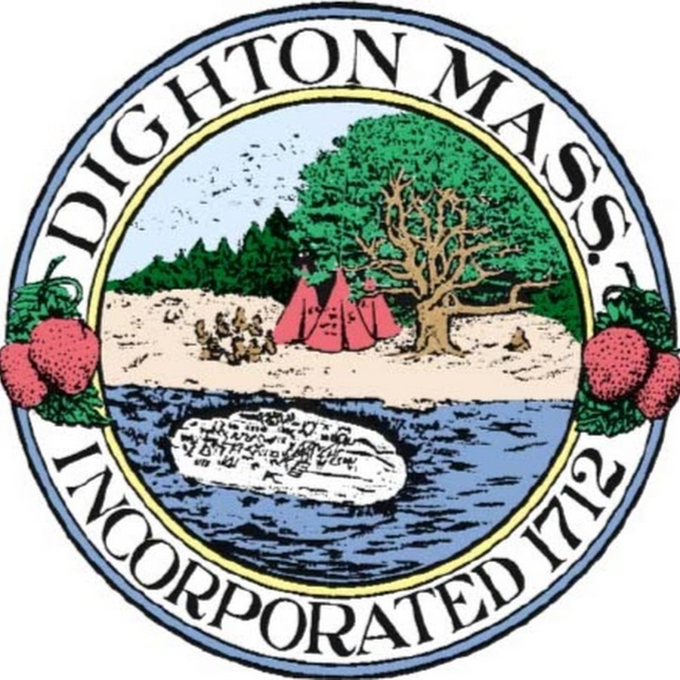

TOWN OF DIGHTON, MASSACHUSETTS
March 23, 2022
Bid Opening: Tuesday, May 31, 2022 at 2:00 p.m.
Michael Mullen, Jr.
Town Administrator / Chief Procurement Officer

REQUEST FOR QUALIFICATIONS (RFQ)
TAUNTON RIVER TRAILS CONNECTION TO DCR SWEETS KNOLL TRAIL FEASIBILITY STUDY
RFQ # 22-01

The Town of Dighton, acting through its Trails Committee, invites proposals from qualified individuals and firms for consulting services related to conducting the Taunton River Trails Connection to DCR Sweets Knoll Trail Feasibility Study.
A copy of the RFQ outlining the requirements for submission is available online or from the Town Administrator at mmullen@dighton-ma.gov. For further information contact Michael Mullen, Town Administrator or mmullen@dighton-ma.gov. The proposal may be viewed and downloaded from the Town website https://www.dighton-ma.gov/department/procurement_opportunities.php.
Proposals are invited and will be received by the Town Administrator, Town of Dighton, Massachusetts on or before 2:00 PM, May 31, 2022 at the Town Administrator’s Office, Town of Dighton Town Hall, 979 Somerset Avenue, Dighton, MA 02715. Proposals delivered after the appointed time and date will not be considered.
A mandatory briefing on the RFQ and the scope of work is scheduled for May 17, 2022 at 3:00 PM at Dighton’s Old Town Hall, 1111 Somerset Avenue. Questions about the RFQ may be submitted by May 24, 2022, at 12 PM. Responses to questions, including those raised at the briefing session, will be sent to those requesting the RFQ and posted online as addenda to the RFQ.
Six (6) copies of the proposal shall be submitted in a sealed envelope marked “RFQ #22-01 – Taunton River Trails Connection to DCR Sweets Knoll Trail Feasibility Study”.
The Town reserves the right to cancel any request for proposals, and to reject in whole or in part any and all proposals, when it is deemed in the best interests of the Town to do so.

REQUEST FOR QUALIFICATIONS
Taunton River Trails Connection to DCR Sweets Knoll Trail Feasibility Study
RFQ 22-01

Responses Due: May 31, 2022 at 2:00 PM
Late Responses Will Be Rejected

Deliver Complete Responses To: Town Administrator
Town of Dighton
Office of the Board of Selectmen
979 Somerset Avenue
Dighton, MA 02715

For Further Information Please Contact: Michael P. Mullen, Town Administrator
Email: mmullen@dighton-ma.gov

RFQ No. 22-01
I. OVERVIEW/ PURPOSE
The Town of Dighton, acting through its Trails Committee, invites proposals from consultants to complete a feasibility study to connect the future 2-mile Department of Conservation and Recreation (DCR) Sweets Knoll Rail-Trail to the fabric of Dighton and part of the Taunton River Trails network. Options for connection of the Sweets Knoll Trail must be determined to the north and south with on-road and off-road trails north across the Three Mile River to the City of Taunton and south along the waterfront to the Town of Somerset.
Specifically, the Trails Committee seeks the professional services from experienced planning, urban design, transportation, or engineering firms qualified to develop a plan for a connection that will address safety and access between the Sweets Knoll Rail-Trail and Taunton River Trails network, identify community goals and priorities, conduct an alternatives analysis of the corridor route and intersection redesigns, and describe an implementation plan for improvements to make the connection a safe, accessible, and enjoyable off-road path for people biking and walking.
The implementation plan will describe next steps for bringing the project to construction and include conceptual designs with preliminary cost estimates that could be further developed into design plans for construction. The implementation plan must be actionable and be able to serve as the basis for future grant applications and project development between local and state stakeholders. It is expected that the consultant will work with the Town of Dighton, the Trails Committee, the state Department of Conservation and Recreation (DCR), the Massachusetts Department of Transportation, the Taunton River Stewardship Council (TRSC), and the Southeastern Regional Planning & Economic Development District (SRPEDD) to prepare the plan. This effort will be informed by a public engagement process as well.
This effort is fully funded through a $40,000 grant from the Taunton River Stewardship Council, stewards of the federally designated Wild & Scenic Taunton River for Fiscal Year 2023. The project must be fully completed by June 30, 2023.
II. BACKGROUND INFORMATION
This project is a feasibility study and concept design to advance the development concepts to connect the future 2-mile Department of Conservation and Recreation (DCR) Sweets Knoll Rail-Trail to the fabric of Dighton. Options for connection of the Sweets Knoll Trail must be determined to the north and south with on-road and off-road trails north across the Three Mile River to the City of Taunton and south along the waterfront to the Town of Somerset.

This overall project will be consistent with three of the six (6) outstanding resource
values of the Wild & Scenic Taunton River to include:

- Estuary promoting Recreational Access and Waterfront Revitalization connecting the Dighton community to the river and its tributaries,
- Recreation and Scenery protecting Connected Open Spaces in the Taunton River corridor as an opportunity for diverse recreational activities, and
- Culture and History promoting the documentation, protection, and preservation of the cultural and historical assets of the Wild & Scenic River.

This overall project is one piece of a larger regional project with efforts to connect the Dighton community to the South Coast Bikeway Alliance's (SCBA) South Coast Bikeway network to the south in Somerset and Taunton Pathway Committee's ongoing trail network in Taunton. These are all key elements in Southeastern Regional Planning & Economic Development District's (SRPEDD) Taunton River Trails vision for a 22+ mile multi-modal trail network in the region.
The DCR was awarded Design and Engineering funding for a 2-mile rail-trail in the heart of Dighton along the Taunton River (DCR POC: Gerald Autler, Director of Trails & Greenways). Figure 1 below illustrates the 2-mile run which spans roughly 1 mile north and south of the Sweets Knoll State Park located on RT-138 in Dighton MA. The northern termination point of the Sweets Knoll Trail is in the vicinity of Sandpiper Way, and the southern termination point is on Somerset Avenue behind Alice’s Last Stop.

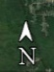
Figure 1: Future DCR Sweets Knoll Rail-Trail

DCR conducted a walk-through with perspective design firms on 21 October 2021 and met with town officials and the trails committee to discuss plans and more recently on 3 March 2022 met virtually with town officials to outline the proposed project plan. Figure 2 provides the outline of the plan recently shared by the DCR with the Town of Dighton.

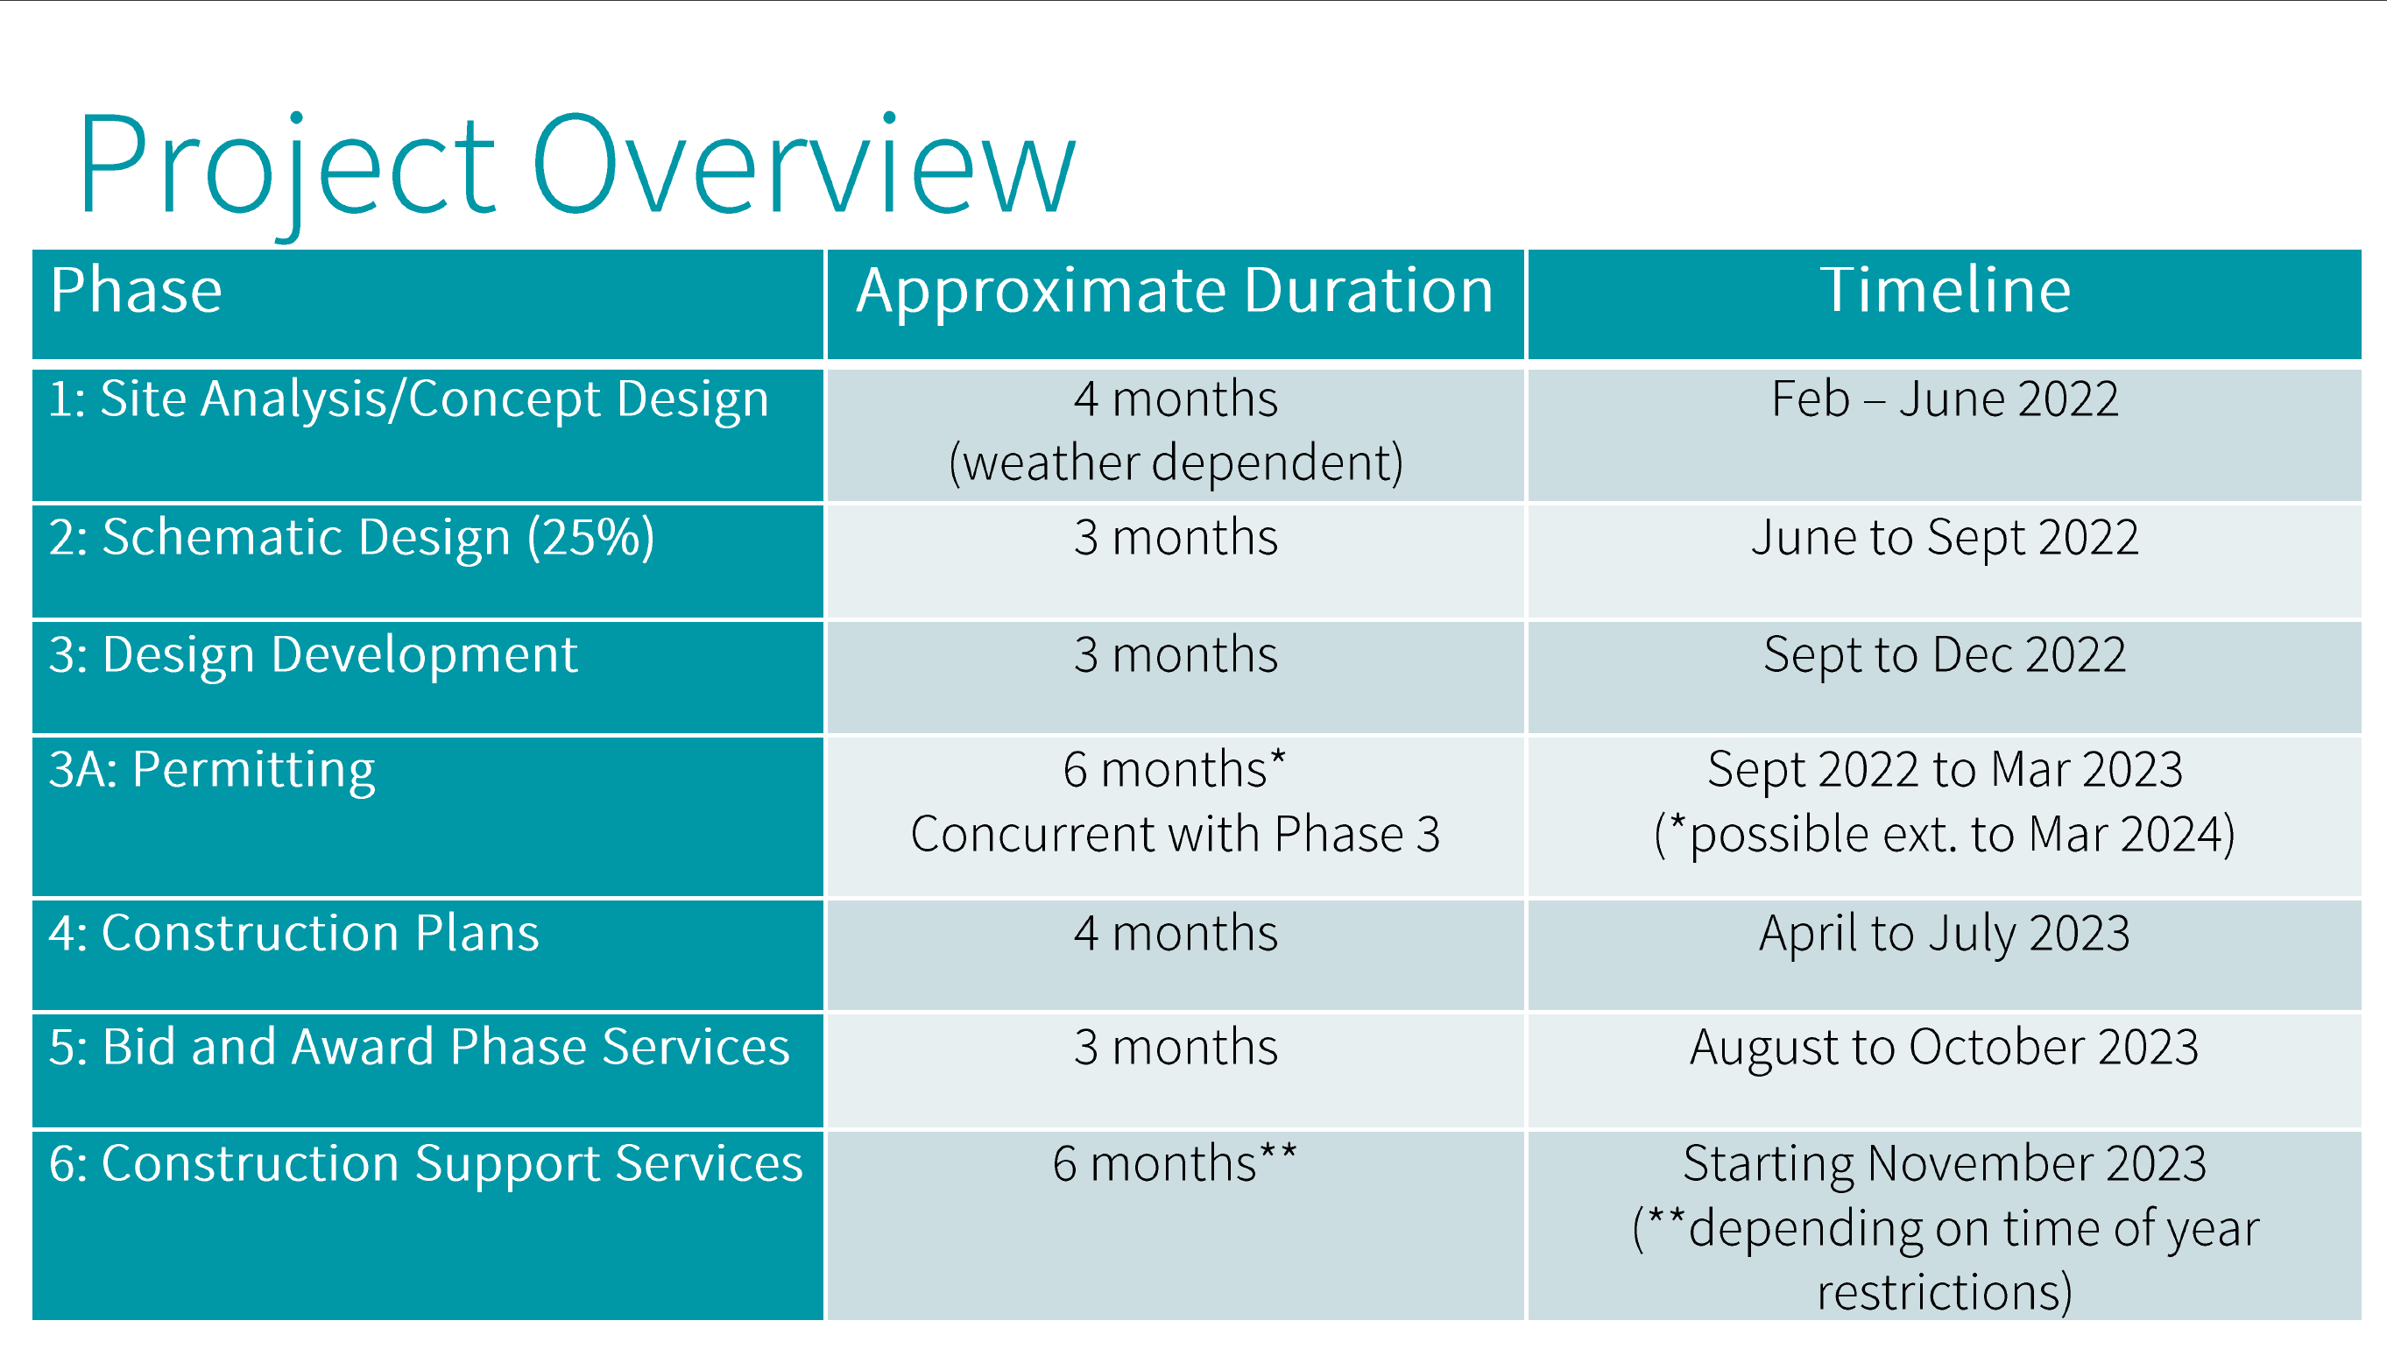
Figure 2: DCR Sweets Knoll Rail-Trail Proposed Design Schedule

This project seeks to examine connection options from the Sweets Knoll Trail departing the terminus points ~0.5 miles north to Taunton and ~2 miles south to Somerset. Portions of these connections may include both on-road and off-road options. Making these connections integrates Dighton with surrounding communities and the Taunton River Trails network regional vision for a 22+ mile multi-modal recreational trail (a vision decades in the making).

This study will produce concepts and rough designs that can be used to pursue additional grants to turn these designs into reality in the coming years with sections portioned off and funds used to build individual elements towards the finished product. This feasibility study and the grants that come afterwards, will fund construction projects that are not only esthetically pleasing, but will last for many years and be an invaluable addition to the Town of Dighton and the regional trails networks.

The Master Plan, OSRP, and Other Key Transportation and Recreational Planning Initiatives
Many recent and current planning efforts recognize the importance of shared use pathways to the Town and suggest strategies for improvement, increasing pathway connections to other land uses, and leveraging paths as critical Town assets.
The Master Plan also envisions broader goals for Dighton, including:
- Open spaces and corridors that link neighborhoods
- Cultural and recreational resources that provide shared experiences
- Natural systems in ecological balance
- A walkable public realm where residents meet their neighbors
The goals of the Master Plan include the protection of open space and the preservation of the Town’s rural character for enjoyment by future generations. Expanding existing open space and recreational areas would also contribute to the goal of creating linkages and connections between these resources. Dighton should strive to develop a more robust open space and recreational network that is interconnected where possible.
The Town recently updated its Open Space and Recreation Plan (OSRP). The plan, updated in 2021, takes into consideration the open space and recreational needs of residents and outlines an action plan to address those needs. A priority of the new OSRP update, is to preserve open space resources while enhancing access to and between them.
III. SCOPE OF SERVICES
The Town of Dighton seeks proposals for professional services from experienced planning, urban design, transportation, or engineering firms qualified to complete a feasibility study for connecting the Taunton River Trails to future DCR Sweets Knoll Trail that will address safety and access between the future DCR Sweets Knoll Trail and Taunton River Trails through Dighton, identify community goals and priorities, conduct an alternatives analysis of the corridor route and intersection redesigns, and describe an implementation plan for improvements to make the connection a safe, accessible, and enjoyable on-road and off-road path for people biking and walking.
The implementation plan will describe next steps for bringing the project to construction and include conceptual designs with preliminary cost estimates that could be further developed into design plans for construction. The implementation plan must be actionable and be able to serve as the basis for future grant applications and project development between local and state stakeholders. The study should include review of safety enhancements and accessibility at at-grade crossings and entry points; “wayside” areas to create a sense of place and providing opportunities to rest, including possible overlooks along the Taunton River; review the feasibility of widening any existing pathways, reconstructing pathways, and building new pathways to provide a trail or sidepath facility; and safety and access improvements at cross streets for people biking and walking. The feasibility study should utilize sustainable planning and engineering approaches to design improvements to water quality, reductions to local flooding, and enhancements of the natural resources of the area. A full list of plan elements is provided below.
Taunton River Trails Connection to DCR Sweets Knoll Trail Feasibility Study
The Taunton River Trails Connection to DCR Sweets Knoll Trail Feasibility Study should include a combination of narrative, diagrams, maps, renderings, data tables, infographics, and other visual forms of communication to effectively convey concepts and data necessary to inform the public. As part of the study development the Consultant should expect to work with an interagency Project Team made up of staff from state and local agencies and local non-profits, including the Town of Dighton, DCR, MassDOT, the Taunton River Stewardship Council (TRSC), and the Southeastern Regional Planning & Economic Development District (SRPEDD). The Project Team will provide guidance and review of the study development at specified intervals as key stakeholders. Day-to-day oversight will be provided by the Town of Dighton in partnership with the Trails Committee.

At a minimum, the following components will be included in the plan:

- A comprehensive assessment of existing conditions of the area, including an infrastructure audit and analysis, a review of existing plans/processes/policies, maintenance practices, entry and access points, ADA access, bridges, proposed and planned new connections, current signage, and engineering plans along the proposed connection from the future DCR Sweets Knoll Trail and Taunton River Trails through Dighton. The analysis will include studying intersections, drainage, lighting, opportunities to add infrastructure (at key nodes, existing and future access points, waysides for staying and resting opportunities, etc.), and current maintenance. A safety assessment of the route for walking and biking, especially where it crosses roadways and intersections, is a critical element of this existing conditions review. The safety assessment should identify high-crash locations, sight distance and road grade issues, high vehicle speeds conflicting with trail user safety and comfort, traffic and pedestrian signals and cycles, crossing locations, and any other pertinent information to evaluate safety. Other key data points that should be collected include but are not limited to base vehicle traffic counts, bicycle/pedestrian usage, public transit ridership, and local land uses. The Consultant shall provide an existing conditions basemap as part of the final plan.

- Develop community goals and priorities for the project and preferred alignment that are in line with and support the Town of Dighton Open Space Recreational Plan (OSRP). A community engagement plan should be developed to gather feedback on these goals and priorities, as well as review the final recommendations and preferred concepts and trail alignment.

- Develop alternatives and preferred options for the alignment of the trail and redesign of intersection crossings that prioritize safety and comfort of trail users. The Consultant must develop several possible options for the trail alignment and intersection crossings that can be reviewed and evaluated by the Project Team and through public engagement. Deliverables expected include plan views of trail sections showing potential trail alignments; concept designs for intersection and safety improvements at conflict points and neighborhood connections; and renderings showing proposed views of the trail to be used for visualization and promotion of the project. Possible trail alignment options and intersection treatments should include information on potential impacts to adjacent properties and natural areas; impacts to vehicle LOS or on-street parking; drainage; traffic signals and traffic control; order-of-magnitude costs; and any other pertinent information to assist the Project Team and the public to determine the most appropriate alternatives. Trail alignment options should also give particular consideration to minimizing disruption of natural areas and reducing impervious surfaces in the federally designated Wild & Scenic Taunton River.
  - Areas where trail routing and facility alternatives may require different approaches and considerations include:
    - Crossing Three Mile River in the vicinity of the Co-Op property, 455 Somerset Avenue, Dighton; Aquaria property at 170 Aquaria Drive, Dighton;
    - Pedestrian traffic in the area of Dighton’s Pleasant Street area; and
    - Other areas along the trail where private property ownership may come into question.
The Consultant should also provide recommendations for interim measures to improve the trail route and the intersections, such as pavement markings, signage, and temporary materials that can be quickly implemented by the appropriate local or state entity.
Additionally, assess ADA accessibility and provide recommendations for improvements.
Finally, assess feasibility of additional amenities to the trail, including viewing platforms along the Taunton River and other placemaking treatments to enhance the trail experience.
- Recommendations for short- and long-term maintenance of the proposed connection, including pavement rehabilitation, vegetation maintenance, bridges, guard rails, fencing, stormwater management, and snow clearance. Recommendations should include cost estimates and staff capacity needs as applicable, as well as the entities responsible for maintenance.

- Create final plan with a recommended trail route and surface material, recommended intersection treatments and redesigns, trail amenities and placemaking treatments, neighborhood connections, and provide an actionable implementation plan for local and state agencies to bring the project to construction. The final recommended route and intersection treatments should include cost estimates for full project design and construction, renderings of the proposed route and plan views of improvements, responsible parties for completing action steps, and recommendations for funding various stages of the project. The plan should include a narrative describing the process by which the final recommendations were selected, pros and cons of other alternatives considered, and public engagement as part of the process to finalize the recommendations. The plan should also include a phasing plan, as appropriate, to implement the recommended improvements of the plan. Concept designs and proposed routing should be at a design stage to allow further development into construction plans at a later date.
Public Meetings and Community Engagement
Due to the current pandemic and enabling legislation to conduct public meetings virtually, it is likely that public meetings and community outreach will occur both in person and via virtual platforms. As the project progresses, this can be revisited if restrictions are changed.
The planning process will include community engagement and input to inform the feasibility study and develop the overarching vision and goals. The Trails Committee anticipates holding up to three (3) public meetings/forums. The first forum should share existing conditions gathered by the consultant as part of the first task and to learn from residents about their experiences, usage, and priorities for the Taunton River Trails Connection to DCR Sweets Knoll Trail. The second community meeting will be to develop a connection vision, goals, and priorities which build off existing conditions and align with the Town of Dighton Open Space Recreation Plan (OSRP). The final community meeting will include discussing recommendations and the final draft plan.
As noted above, the Consultant should expect to work with an interagency Project Team made up of staff from state and local agencies and local non-profits, including the Town of Dighton, DCR, MassDOT, the Taunton River Stewardship Council (TRSC), and the Southeastern Regional Planning & Economic Development District (SRPEDD). The Project Team should meet at least four times (quarterly) to review the status of the project and provide feedback on the progress and development of the study’s final recommendations as described above.
We expect the Consultant to design a public engagement strategy that is creative and engages with a wide variety of stakeholders and hard to reach populations as much as possible to meet our goals to provide an equitable and inclusive process.
Staff Role
Town of Dighton, DCR, MassDOT, the Taunton River Stewardship Council (TRSC), and the Southeastern Regional Planning & Economic Development District (SRPEDD), will be closely involved. Communication with DCR and MassDOT will be necessary due to interfaces to their property interests along Rt 138 and the Sweets Knoll Trail. The Consultant is expected to devote the time needed to conduct research, write documents, and participate in public meetings and Project Team meetings as described above, and also regularly communicate with Dighton and Trails Committee staff for oversight and general project guidance. Additionally, staff will take primary responsibility for scheduling meetings, posting notices for meetings, preparing meeting minutes, and attending all meetings. Staff will provide any reasonably necessary baseline data, GIS data and layers, and access to documentation including relevant plans, and any other relevant materials in electronic format.
IV. PROJECT SCHEDULE
Work is expected to start Summer 2022. This project must be completed by June 30, 2023 as required by the Town’s Grant Agreement with TRSC. The Consultant shall prepare a reasonable schedule to complete the project within this timeframe.
V. DELIVERABLES
The Consultant will deliver four (4) copies of all reports produced, along with high-quality electronic copies of the same in a Microsoft Word compatible version and a searchable PDF version that is ADA-compliant. Any data collected in support of the plan shall be provided to the Project Team, including GIS data and background data for charts and graphs. GIS data should be included in Map Package format that can be opened in ArcGIS. All materials will become the property of the Town of Dighton, Taunton River Stewardship Council (TRSC), and the Southeastern Regional Planning & Economic Development District (SRPEDD).
VI. CONSULTANT QUALIFICATIONS
At a minimum, the proposing firm/team must meet the following requirements:
- The firm/project manager/team must have at least five (5) years of experience in one of the following practice areas: alternative transportation modes focused on bicycle/pedestrian planning, urban design and landscape architecture, engineering on projects of similar size and scope, with a particular emphasis on trail or shared-use path planning.
- The firm/project manager/team must have at least five (5) years of community engagement and outreach experience.
- The firm/team must have previous experience in similar projects. Successful completion of a minimum of three (3) similar projects within the last five (5) years is required, and completion of five (5) overall is desired.
- The principal and project manager to be assigned to this project must be available for meetings with the Town on days or evenings, as required.
- The firm/team must have proven planning and community development experience in the public and/or private sector and in working with municipalities, specifically demonstrated experience in planning and designing trail and rail trail systems.
- The volume of the proposed project managers and firm's current and projected workload must not adversely affect its ability to immediately initiate work and to follow through with the project in a timely and professional manner. The firm and all team members must be current staff members and capable of devoting a significant amount of time to this project in order to complete the work within the schedule outlined in this RFQ.
VII. SELECTION CRITERIA
The Town will award the contract to the Consultant offering the most advantageous response to this RFQ, taking into consideration all evaluation criteria. The selection process will include an evaluation procedure based on the criteria identified below. Finalists may be required to appear for an interview.
- Staffing Plan, including the professional qualifications of all project personnel with particular attention to training, educational background, professional certification or registration, and professional experience. Demonstrated expertise and experience of the Principal-in-Charge, Project Manager, and other key personnel, and any Consultants to be assigned to the Project, including professional registration of the Consultants and their qualifications. The Plan of Services should be detailed and logical, and demonstrate efficiencies and creativity in completing the project.
  - Highly Advantageous: The plan of services proposes a detailed, logical, creative, collaborative, and highly efficient scheme for producing a complete project that addresses all Goals and Priorities of this project and meets all the minimum applicant qualifications detailed in Section VI, “Consultant Qualifications”.
  - Advantageous: The plan of services proposes a credible scheme for producing a complete project that addresses all of the required issues and meets all the minimum applicant qualifications detailed in Section VI, “Consultant Qualifications”.
  - Not Advantageous: The plan of services is not sufficiently detailed to fully evaluate, or the plan does not contain all the components necessary to produce a complete project that addresses all of the required issues and meets all the minimum applicant qualifications detailed in Section VI, “Consultant Qualifications”.
  - Unacceptable: The plan of services does not meet all the minimum applicant qualifications detailed in Section VI, “Consultant Qualifications”.
- Depth of experience in alternative transportation modes focused on bicycle/pedestrian planning, urban design and landscape architecture, engineering on projects of similar size and scope, with a particular emphasis on trail or shared-use path planning. It shall also be advantageous for the proposer to provide evidence that completed planning or feasibility projects led to further construction of the trail projects that were studied.
  - Highly Advantageous: The Consultant has at least five (5) years of experience consulting with municipalities on trail planning projects of similar size and scope to this project. The Consultant can demonstrate the successful completion of five (5) similar trail or shared-use path planning and/or feasibility study projects within the last five (5) years. All feasibility studies completed are demonstrated to have led to further project implementation and/or construction.
  - Advantageous: The Consultant has at least four (4) years of experience consulting with municipalities on trail planning projects of similar size and scope to this project. The Consultant can demonstrate the successful completion of four (4) similar trail or shared-use path planning and/or feasibility study projects within the last five (5) years. Some feasibility studies completed are demonstrated to have led to further project implementation and/or construction.
  - Not Advantageous: The Consultant has less than three (3) years of experience but more than one (1) year consulting with municipalities on trail planning projects of similar size and scope to this project. The Consultant can demonstrate the successful completion of three (3) similar trail or shared-use path planning and/or feasibility study projects within the last five (5) years. Feasibility studies referenced have not led to further project implementation and/or construction.
  - Unacceptable: The Consultant has less than one (1) year of experience consulting with municipalities on trail planning projects of similar size and scope to this project. The Consultant cannot demonstrate the successful completion of similar trail or shared-use path planning and/or feasibility study projects.
- Responsiveness of proposal, including a demonstrated understanding of all project components, creativity in addressing trail and shared-use path issues, and public outreach needs.
  - Highly Advantageous: The response contains a clear, creative, and comprehensive plan that addresses all project Goals and Priorities as stated in the RFQ.
  - Advantageous: The response contains a clear plan that addresses most of the project Goals and Priorities as stated in the RFQ.
  - Not Advantageous: The response does not contain a clear plan to address many of the project Goals and Priorities as stated in the RFQ.
  - Unacceptable: The response does not contain any plan to address the project objectives stated in the RFQ.
- Strength and credibility of client references. The Consultant shall demonstrate prior client satisfaction with working relationship, project management capabilities, meeting project budget and schedule, and technical expertise in developing similar projects. References should aim to include clients who have worked with the designated Principal and/or project manager.
  - Highly Advantageous: More than three clients who consider your services satisfactory or better. Projects were completed within budget and on schedule with minimal, insignificant delays.
  - Advantageous: Three clients who consider your services satisfactory or better. One of the Consultant's references indicates that the project was not completed within budget attributable to the Consultant or with substantial delays attributable to the Consultant, and no current project or project completed in the last three years experienced substantial delays attributable to the Consultant.
  - Not Advantageous: Three or more clients not all of whom consider your services satisfactory or better. Two of the Consultant's references indicate that the project was not completed within budget attributable to the Consultant or was completed with substantial delays attributable to the Consultant, and no current project or project completed in the last year experienced substantial delays attributable to the Consultant.
  - Unacceptable: Fewer than three clients who consider your services satisfactory or better, or three or more clients who consider your services unsatisfactory. More than two of the Consultant's references indicate that the project was not completed within budget attributable to the Consultant or was completed with substantial delays attributable to the Consultant.
VIII. SUBMITTAL REQUIREMENTS
Interested qualified firms must submit a response addressing the objectives, scope and schedule described in this RFQ. Responses must include, at a minimum, each of the following:
- Six (6) paper copies of the proposal submitted in a sealed envelope marked “RFQ#22-01 – Taunton River Trails Connection to DCR Sweets Knoll Trail Feasibility Study - Technical Proposal”.
- General description of the firm/team's experience.
- Description, with examples, of the firm/team's experience in working with municipalities or private clients to successfully create and implement trail plans and policies and engage the community in the process.
- A detailed scope of services for the proposed work, including the firm/team's general approach to such work, evidence of the firm/team's understanding of the goals and objectives of the project, and methodology for accomplishing the tasks as listed in this RFQ.
- An outline of the schedule for completion of tasks (timeline) as presented in the firm/team's approach to the scope of services.
- Description of or resumes for the assigned staffs’ experience, educational background, availability, and chain of responsibility, including the name and title of the principal and project manager assigned to the project, names of all sub-consultants, and resumes of all personnel to be associated with the project.
- At least three (3) references, including name, title, agency, address, description of project, project cost, and telephone number and the email address for clients with similar projects completed by the Consultant within the last five years (including dates).
- List and contact information for all public sector design projects undertaken in the Commonwealth of Massachusetts in the last five years including descriptive information for projects comparable to this project as outlined herein.
- Other pertinent information about the firm(s) that would aid the Town in making a selection.
- Completed Required Forms.
- Evidence of insurance coverage, including general and professional liability and Workers’ Compensation insurance.
Proposals must clearly address all the submittal requirements; that is, the response should include a section addressing all the minimum qualifications, the minimum submittal requirements, and each of the review criteria. The proposal will be reviewed based on each of these items and it will be to the benefit of the responder to clearly address each of the items. Where the requirements specify a minimum level of experience, indicate the dates of said experience.
The proposal shall contain the names and contact information (including email addresses) of current and past public and private clients over the past five years that the Town may interview related to the applicants’ project performance. Preference will be given to applicants who have demonstrated a high degree of client satisfaction related to work product, client service and the ability to meet the prescribed deadlines.
A Selection Committee will be convened to review proposals. Committee members will be drawn from Town staff, Trails Committee, Taunton River Stewardship Council (TRSC), the Southeastern Regional Planning & Economic Development District (SRPEDD), and other community stakeholders.
The Town reserves the right to reject any or all proposals, to waive any non-material irregularities or information in any RFQ, and to accept or reject any item or combination of items. The Town also reserves the right to seek additional information and revised proposals prior to selection of a Consultant through written notice to all the respondents.
A mandatory project briefing session will be held on May 17, 2022 at 3:00 PM at Dighton’s Old Town Hall, 1111 Somerset Avenue, Dighton. Questions may be submitted to Michael Mullen, Town Administrator at mmullen@dighton-ma.gov or at (508) 669-6431 (Option 1) by May 24, 2022, at 12 PM. Responses to questions, including those raised at the briefing session, will be sent to those requesting the RFQ and posted online as addenda to the RFQ.
Responses to the RFQ are due by 2 PM on May 31, 2022. Facsimile and/or emailed responses will not be accepted. All responses should be submitted to:
Michael P. Mullen, Jr.
Town Administrator
Town of Dighton
979 Somerset Avenue
Dighton, MA 02715

Interviews with prospective consultants will be scheduled June and July 2022.
IX. FEE NEGOTIATIONS
Following completion of interviews the Town will select a first ranked designer. The Town will negotiate with the first ranked designer on the list of finalists. Should the Town be unable to negotiate a satisfactory fee with the first ranked designer, negotiations will be terminated and negotiations undertaken with the remaining designers, one at a time, in the order in which they are ranked, until an agreement is reached. The proposal must not contain any mention or price for cost for services. The designer’s fee will be negotiated, not to exceed $40,000.00 in total, including all reimbursable and sub-consultant expenses, including additional hazardous materials testing, if required.
X. FINAL DESIGN SERVICES
The Town of Dighton reserves the right to be able to contract with the same design firm for the feasibility study and final design services phase, including the development of final plans and specifications, bidding oversight, and construction administration services, without an additional RFQ process.
XI. REQUIRED FORMS
All required forms must be submitted with the proposal.
  - Certificate of Non-Collusion
  - Certificate of Tax Compliance

CERTIFICATE OF NON-COLLUSION FORM
TOWN OF Dighton
Taunton River Trails Connection to DCR Sweets Knoll Trail Feasibility Study

The undersigned certifies under penalties of perjury that this bid or proposal has been made and submitted in good faith and without collusion or fraud with any other person. As used in this certification the word “person” shall mean any natural person, business, partnership, corporation, union, committee, club, or other organization, entity, or group of individuals.

_________________________________________________
Signature of Individual Submitting Bid or Proposal

_________________________________________________
Name of Individual Submitting Bid or Proposal

___________________________________________________________
Name of Business

_____________________________________
Date

BY STATE LAW THIS NON-COLLUSION FORM MUST BE SIGNED AND SUBMITTED WITH THE BID OR PROPOSAL.

CERTIFICATE OF TAX COMPLIANCE FORM
TOWN OF Dighton
Taunton River Trails Connection to DCR Sweets Knoll Trail Feasibility Study

Pursuant to MGL Chapter 62C, Section 49A, I certify under the penalties of perjury that I have complied with all laws of the Commonwealth of Massachusetts relating to taxes, reporting of employees and contractors, and withholding and remitting child support.

________________________ _______________________________________________
Social Security Number or Signature and Title of Individual or
Federal Identification Number Responsible Corporate Officer

BY STATE LAW THIS CERTIFICATE OF TAX COMPLIANCE FORM MUST BE SIGNED AND SUBMITTED WITH THE BID OR PROPOSAL.

https://www.dighton-ma.gov/government/planning_board/
https://www.dighton-ma.gov/government/open_space_committee
Some older information may only be available in a hard copy format.

